**PyCity School Analysis**

As requested by the school board, I was given the standardized test results along other school data from each of the schools that are in our district to provide some insight on how best to make future strategic decisions to improve the quality of education in the district. I explored the data both at a district level and then also at the individual school level in order to provide you with a high level overall, but also some insight that will highlight differences between our different schools.

Additional details are included in the report below but in quick summary:

* Charter schools are significantly out-performing the District Schools
* Test scores are relatively flat by grade level
* Math test scores contribute more to the differences in overall passing percentage than do reading scores

District

Looking at a high level overview, we are failing as a whole as a district in achieving acceptable levels of students who can pass both the reading and math standardized tests. The table below details the district data summary and showing that only 65% of our total students pass both tests.



Schools

To better understand where the district is performing well and where it is not, data from individual schools was analyzed. Each school was compared by the following metrics:

* School type – district or charter
* Total students
* Total school budget
* School budget per student (to normalize the budgets for differing school sizes)
* Math scores – school average and percentage of students that passed
* Reading scores – school average and percentage of students that passed
* Overall passing percentage – students that passed both the match and reading tests

Results from this analysis are summarized in this table:

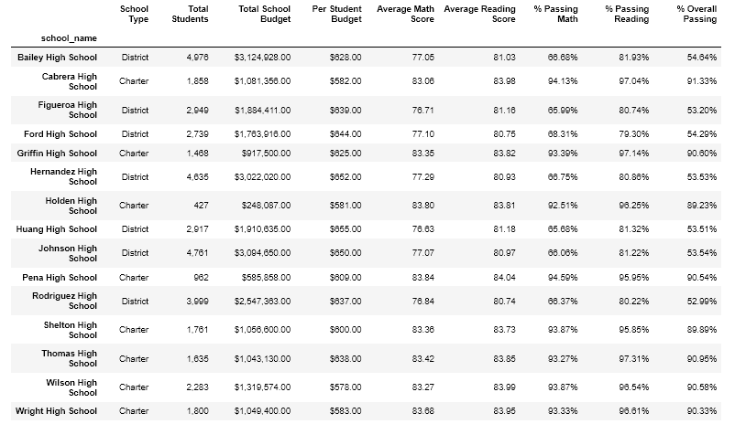

As a quick comparison, the above data was summarized in 2 tables – one for the Top 5 schools in terms of the % Overall Passing score and a second table for the Bottom 5 schools.

Top 5 schools for % Overall Passing scores

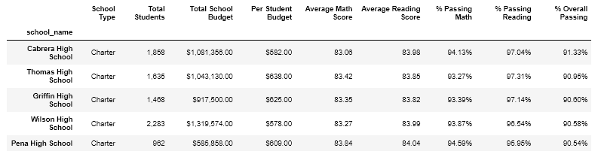

Bottom 5 schools for % Overall Passing scores

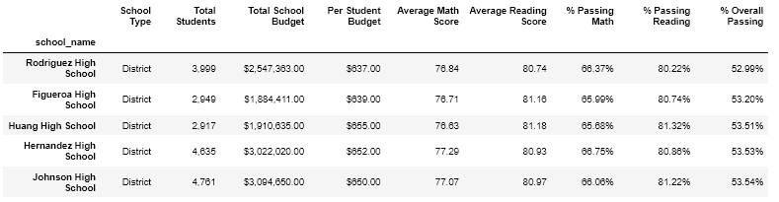

There are several observations from this data that quickly stand out and warrant some additional analysis in the future:

* The Top 5 schools are all Charter schools while the Bottom 5 schools are all District schools. Additional data will be required to dissect this information further
* The total budget per student is surprising lower in the Top 5 schools than in the Bottom 5 schools indicating that the differences won’t be resolved by just throwing additional money at the lower performing schools
* Math scores have a larger drop from the Top 5 to the Bottom 5 schools than do the reading scores – although both metrics did decline.

The school data was further dissected by looking at data by the additional metrics:

* Test scores by grade level
* Test scores by the amount of money spent at each school per student
* Test scores by school size
* Test scores by school type

Based on the summarized data in the following table, each school’s test scores are relatively flat for both reading and math across all of the grade levels.

**Math scores by grade level** **Reading scores by grade level**

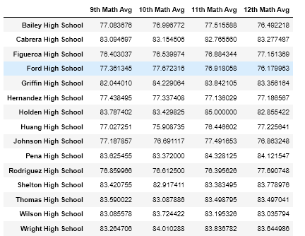 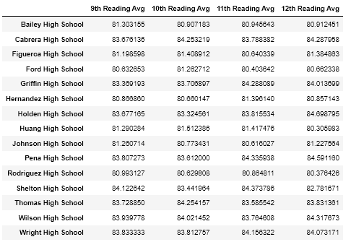

The results for test scores based on per student budget, school size, and school type are summarized in the following tables and show some trends that warrant additional data analysis:

* Schools with lower budgets per student outperformed schools with higher spending (this could also be potentially influenced by school size or type)
* Schools with less than 2000 students performed significantly better than the schools with greater than 2000 students (this needs to be further dissected within each size category to see if additional influences are involved)
* Charter schools are significantly out performing District schools. Additional data will be needed to determine the root cause of this discrepancy other than school size.

Test scores by per student budget

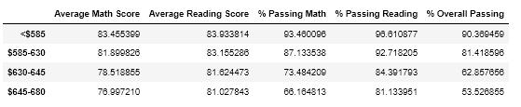

Test scores by school size

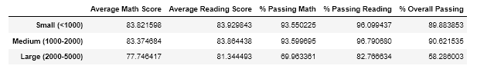

Test scores by school type

